My submission for this milestone includes my python files for the following:

* Connection via venv to SQL server (sql_connect.py)
* Creation of table (create_table.py)
* Database seed data
* Unit test for create_table.py (test_query.py) – in this test case I am shamelessly asserting that my name is present in the database seed records

Please note that I am still troubleshooting an issue in my venv “Error while connecting to MySQL Not enough parameters for the SQL statement”. I have scoured the interwebs for the answer and any of the solutions out there do not seem to be the answer.

1. My seed data is in the same directory as my create_table.py, so I believe it is not a mapping issue
2. I also receive positive feedback from the infoLoop I have created in my “create_table.py” program that indicates I am connecting to the database and have created the patentData table (see screenshots below from both DataGrip and PyCharm’s debug console:

DataGrip:

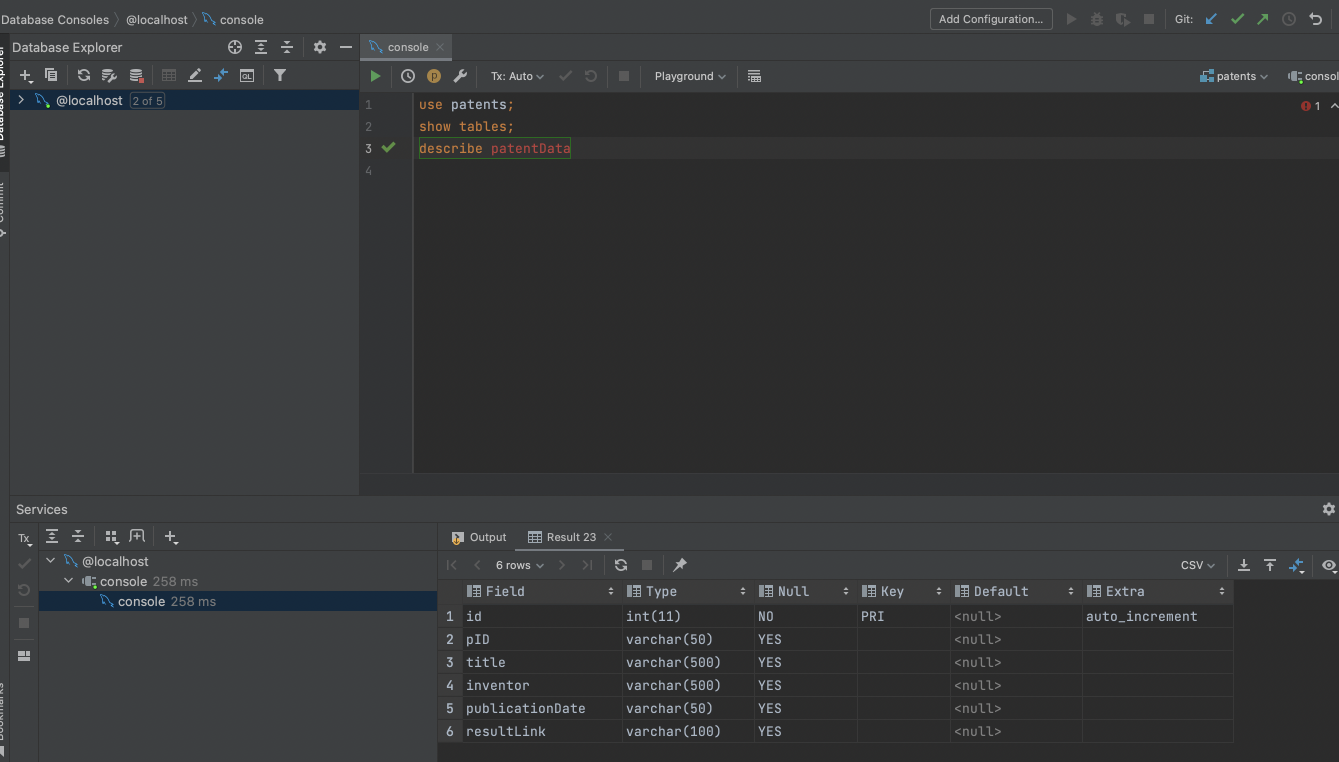

PyCharm:

Observations:

* I know I am connecting to the database server and creating a database, thus I am inserting data into the database
* I also know that I am creating the table but am having issues with the translation of the data read in from pandas and mapping that to the database. I have also included this seed data in the hopes you can help me determine why I am receiving the SQL error “Error while connecting to MySQL Not enough parameters for the SQL statement”. I have verified the number of categories in the csv file as five, and I am adding what I believe to be the appropriate number of variables in the INSERT statement to account for the created ID and Primary Key (id). So, this will probably require tearing down the existing database and table to make the pythonic approach work. Any thoughts would be appreciated.

Ultimately, I was not able to run my unit test because either (1) my data was not being read in cleanly, or (2) my data columns are not matching the table in my DB.